INSTALLATION INSTRUCTIONS
- Install end cap(s) as needed
- Slide end cap into the screen track (over screen) push until tight against panel. Place panel tight against end cap to start your run.
- Fastening Hydro Flo
- Make sure front of panel is over nose of gutter
- Screw #8 x 1/2” screw at each end and one in the middle (screws included).
- For 8’ panels, place screws approx. every 24” apart.
- Hydro Flo is designed to fit snugly under the drip edge against the back of the fascia.
- Screw #10 x 1” screws to the back of the panel into the fascia.
- IMPORTANT: DO NOT screw #10 x 1” screw to the front of the panel as it will most likely result in some distortion of the panel and gutter.
- Measure the end of run and cut panel using snips or a metal saw, ensure end caps are firmly inserted.

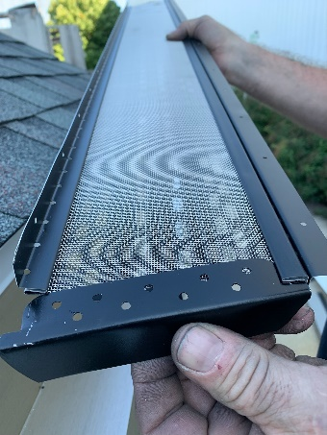 1. 2. 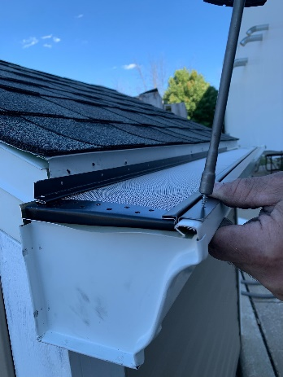
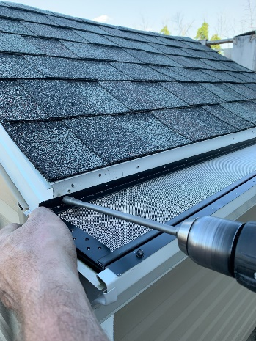 3. 4. 