Maxx Flo Outlet Installation Instructions For  NEW Installation.  Step 1:  Place template at desired location on the bottom of gutter and tape ends of the template to the gutter. Score on slash line (cut through template and into the gutter) from one corner to the other with a utility knife.  Step 2:  Remove template and re-score the “x” with utility knife (Note do not go past the end of the lines). Keep scoring the lines until you get through the gutter OR drill a hole on the “x” and cut using a pair of tin snips. | Step 3:  Trim off the end pointed pieces of the tabs with Tin Snips  Step 4:  With a pair of pliers bend all 4 tabs straight down.  Step 5:  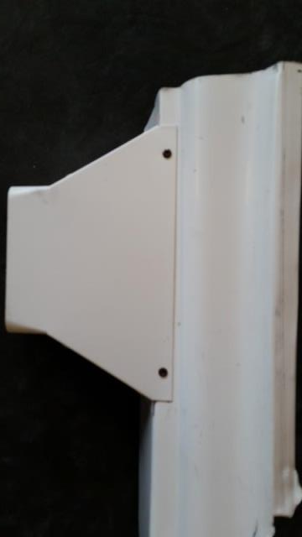  Maxx Flo Outlet is installed on the bottom of the gutter. Place the Maxx Flo Outlet over the folded down tabs and secure the Maxx Flo Outlet to the gutter’s front and back wall (The picture above shows screw location using the pre-punched holes in the outlet. Secure with screws provided.
Maxx Flo Outlet Installation Instructions For
Retro-Fit Applications:
Step 1:  Remove the existing downspout elbow and drop outlet and repeat steps 1 through 4 of NEW Installation Instructions (Above)  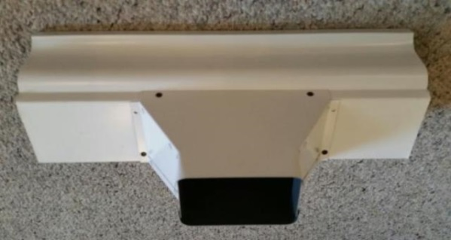 | Step 5:  Maxx Flo is installed on the bottom of the gutter.  Place the Maxx Flo Outlet over the tabs you created by cutting the bottom of the gutter in steps 3 and 4. Secure the Maxx Flo Outlet to the gutter using the screw holes in the front edge and also the back two holes on the bottom pan (1 on each side)- using the pre-punched holes. Secure with screws provided  Picture at left shows the 4 holes (black dots) to use to fasten the outlet to the gutter. 2 in front wall of outlet and the 2 back holes (1 on each side) on the bottom of the gutter.
Tools needed: Utility Knife- Pliers- Tape- Tin Snips- Drill- ¼” Driver Head- Drill Bit (Optional- See Step 2)

